**Conflict in Central African Republic (CAR) Across Time**

Context: Since 2003, Central African Republic has been in a state of civil unrest and multiple civil wars have occurred during that time. They can largely be outlined in four phases: the Bush War (2003-2007), the Seleka overthrow of President Bozize (2012-2013), fighting between the Ex-Seleka militias and Anti-Balaka forces, and battles between the government and the CPC rebel group.

**Bush War (2003-2007):** after Francois Bozize seized the presidency in 2003, rebel groups began fighting with government forces. Multiple rebel groups, the largest of which was the Union of Democratic Forces for Unity (UFDR), began seizing towns in the Northern regions and making their way towards the capital Bangui. A ceasefire was signed in April 2007 by the UFDR and government forces, and other smaller rebel groups signed ones shortly thereafter.

**The Seleka overthrow (2012-2013):** remaining rebel groups who fought with the government following the 2007 ceasefire joined forces to form the “union” or Seleka, in order to overtake the government following accusations that President Bozize had not abided by the agreements of the ceasefire. The Seleka gained additional rebel group support and seized more territory, ultimately forcing President Bozize to enter into peace discussions. A ceasefire was ageed upon in early 2013, which required Bozize to change the Prime Minister and that he could stay in power until the 2016 election. The Seleka forces were not required to give up any cities they had occupied. However, in only two months, the Seleka forces took back up arms when their demands to be integrated into the national army, release of political prisoners, and the removal of South African troops were not met. After taking over towns near Bangui, they overtook the Presidential Palace and forced Bozize to fleee to the Demographic Republic of Congo. Seleka leader turned President Michel Djotodia was declared President in March 2013 and disbanded Parliament immediately .

**Ex-Seleka and Anti-Balaka conflict (2014-2020):** there was immediate unrest in Bangui following the overtaking by the Seleka. Although not an overtly religious movement, the Seleka members are primarily Muslim. When Djotodia disbanded the Seleka militia in 2014, many former members returned to the countryside, where instances of executions, rape, and looting began to increase. Several of these members splintered from the Seleka to form their own rebel groups during this time, including the FPRC, UPC, MPC, and RRR (3R), the former of which demanded independence for the predominantly Muslim north. Concurrently, many Christian militias known as the Anti-Balaka formed to fight the Seleka Militia and its allied groups. As a result of these tensions, the United Nations established the MINUSCA peacekeeping mission in September 2014 to contain the violence. Djotodia stepped down from the Presidency in January 2014 and was replaced by Catherine Samba-Panza, who was largely seen as neutral. Although she attempted to get both sides to put weapons down and a ceasefire was reached in July 2014, a wave of violence against Muslim civilians worsened shortly thereafter.

**Russian mercenaries and government forces against the CPC (2020-Present)**: after multiple delayed attempts to hold Presidential elections from 2020-2021, Faustin-Archange Touadera was declared the winner after having won in 2016. Former President Bozize, together with leaders of the RRR, FPRC, UPC, and some Anti-Balaka forces, formed the Coalition for Patriots of Change (CPC), a rebel group aimed to overturn the results that they claim Touadera had rigged. As a defense tactic against the CPC, Touadera has largely relied on Russian mercenaries – most notably the Wagner Group – to push the CPC back. These mercenaries have won back towns such as Bria and Kaga-Bandoro, severely weakening the CPC. Many additional attacks led by the Wagner Group have taken place in the North regions, particularly in areas where artisanal miners work.

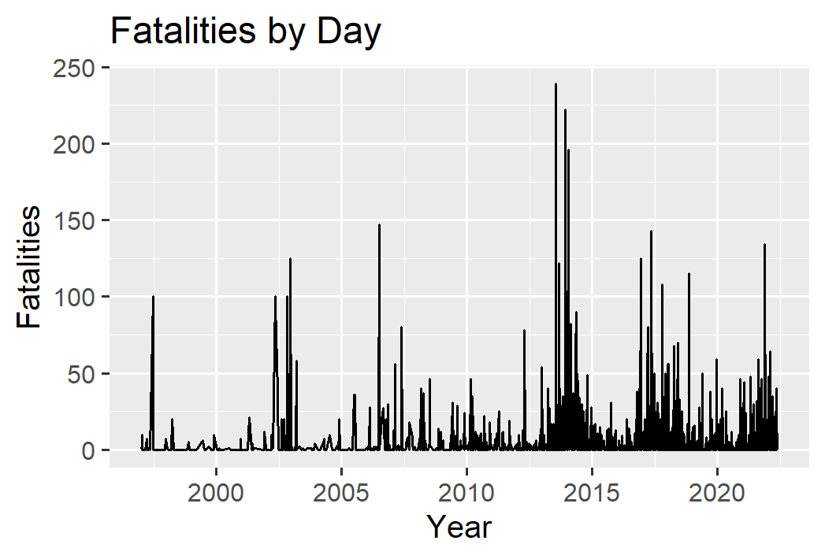

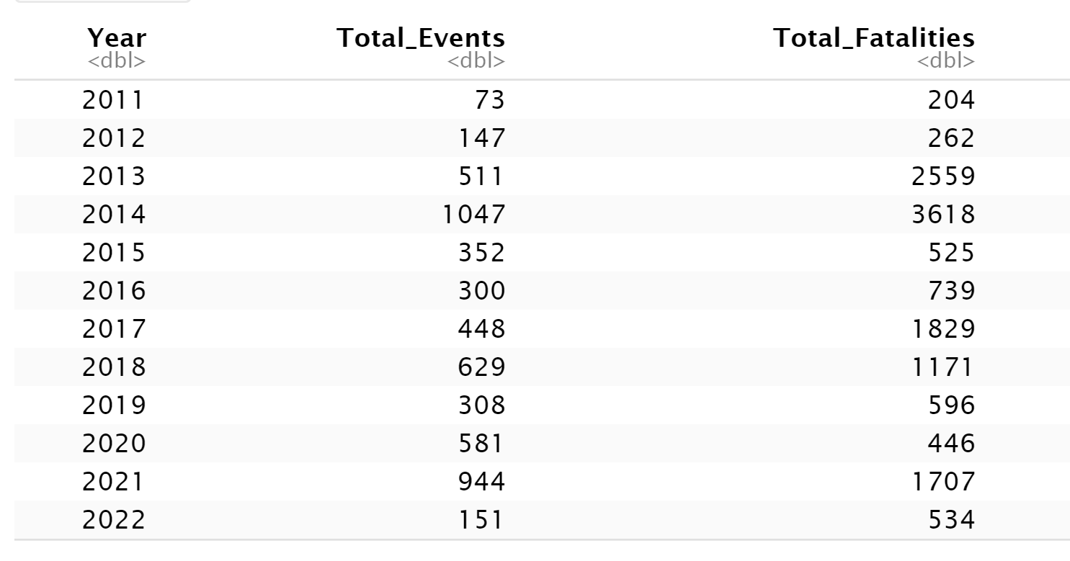

Conflict in the Central Africa Republic occurs in waves and current evidence suggests that the country is currently in the middle of one. Since the ceasefire of July 2014 between the Anti-Balaka and Seleka Militia forces, conflict had ebbed and flowed in two year increments.

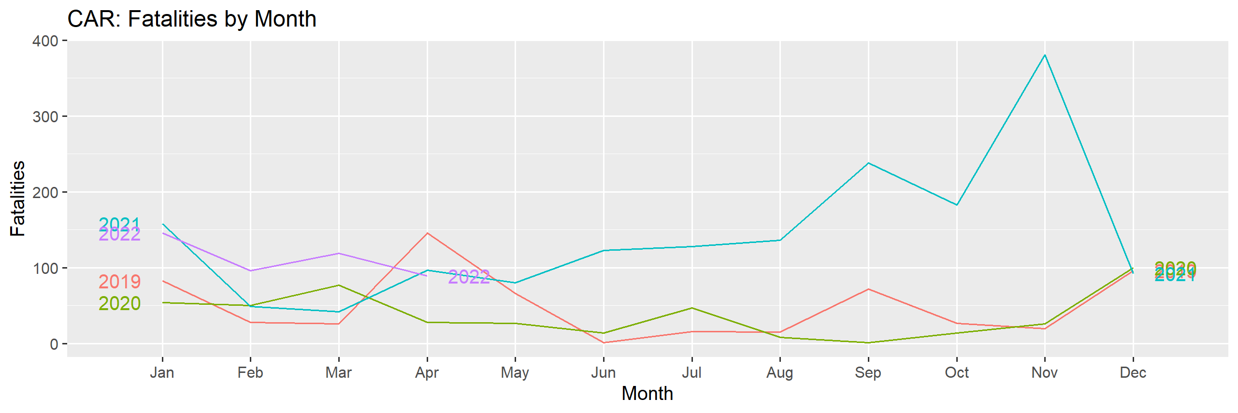

Thus far in 2022, the total number of fatalities attributed to armed conflict has remained below the intense levels of the end of 2021 and has regressed to the levels exhibited in the beginning of 2021. While it is a positive that violent conflict has decline from the height of 381 fatalities in the month of November 2021, the current levels of fatalities – roughly 80-120 per month in 2022 - are still very high even in the recent history since the ceasefire.

**Analysis of Conflict by Region**

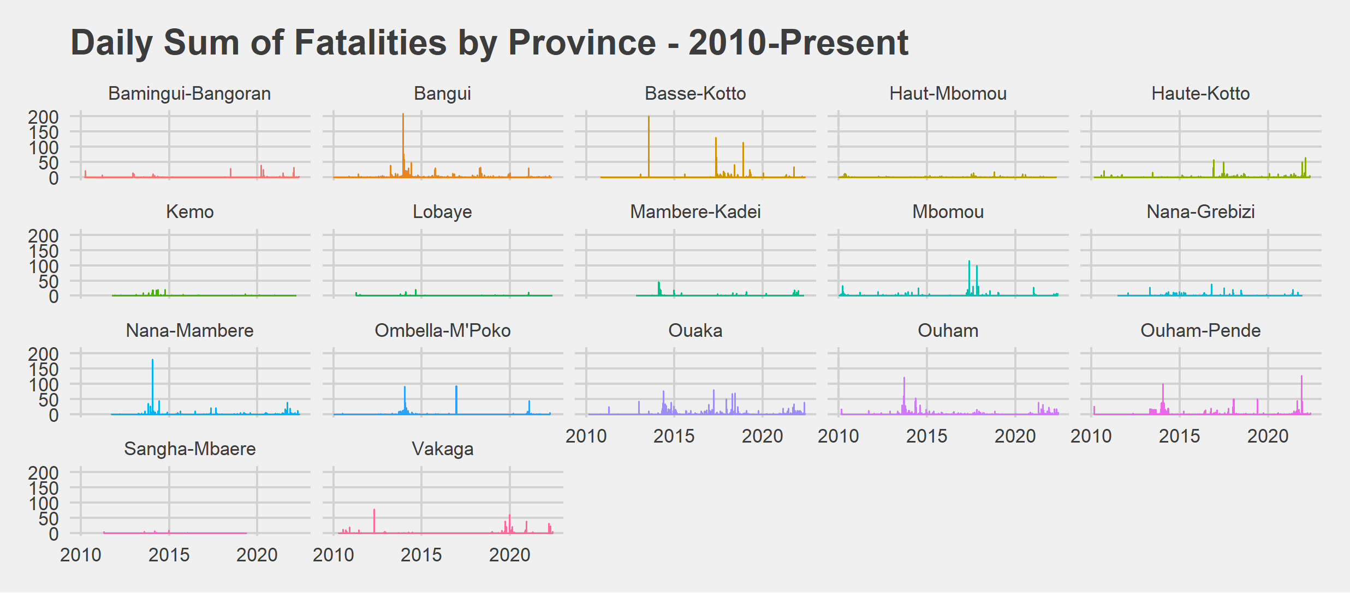

The concentration of conflict events has shifted since 2014 from the capital Bangui to the northwestern provinces of Ouham-Pende and Ouham and the central provinces of Haute-Kotto and Ouaka. These prefectures are also where many gold and diamond mining sites are located, which has been frequently cited as a source of conflict in recent years. A very simple correlation of the total number of fatalities and percent of violent events referring to mining activities suggests some evidence of this relationship, although caution is advised given the small number of prefectures as a unit of analysis and further analysis of this relationship is suggested.

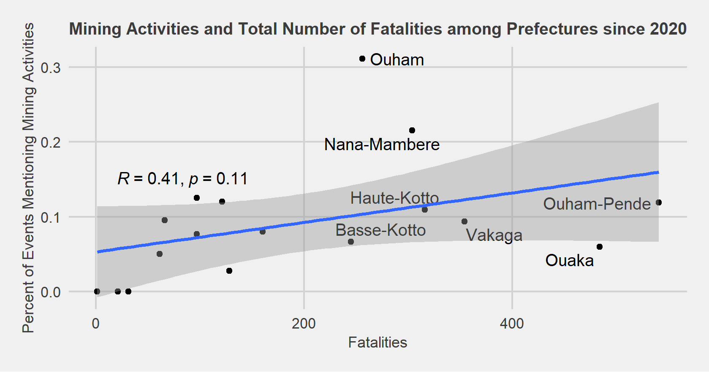

**Actor Analysis**

Number of Violent Events between Key Actors, January 2018 - Present

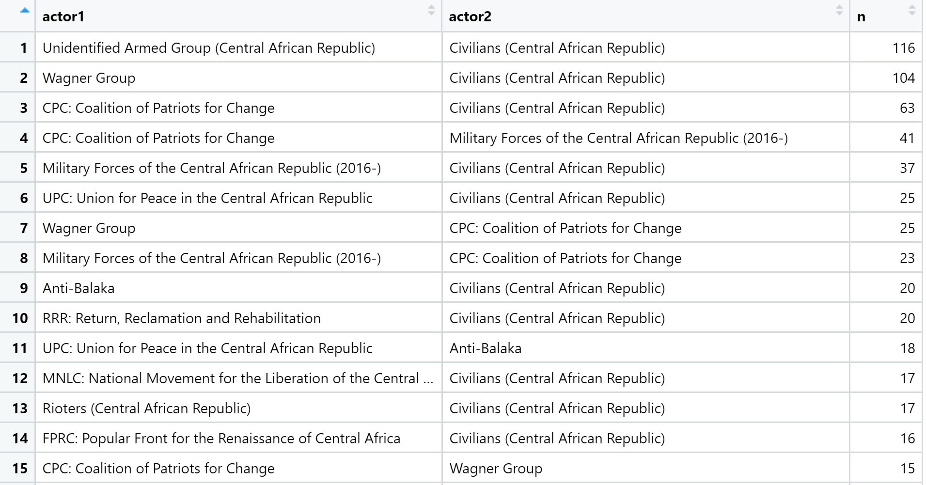

The most notable aspect of armed conflict in the Central African Republic is the extremely high number of events and violent events involving acts of aggression of non-state actors towards local populations. While the Russian-led Wagner Group and the CPC are the main actors committing these offenses in recent years, the frequency of violence against civilians involving other main non-state actors including the FPRC, UPC, Anti-Balaka, and RRR groups is still very high. It is also noteworthy that violence against civilians has persisted in prior time periods of intense conflict between other actors, such as the events prior to 2014. In this sense, the damaging legacy of ethnic tensions between the Muslim Seleka Militia and Christian Anti-Balaka forces from 2013-2014 that targeted civilians has carried over to events involving new actors, regardless of actor or region.

Cluster Network Graph: Conflict between Principal State and Non-State Actors. January 2021 - Present

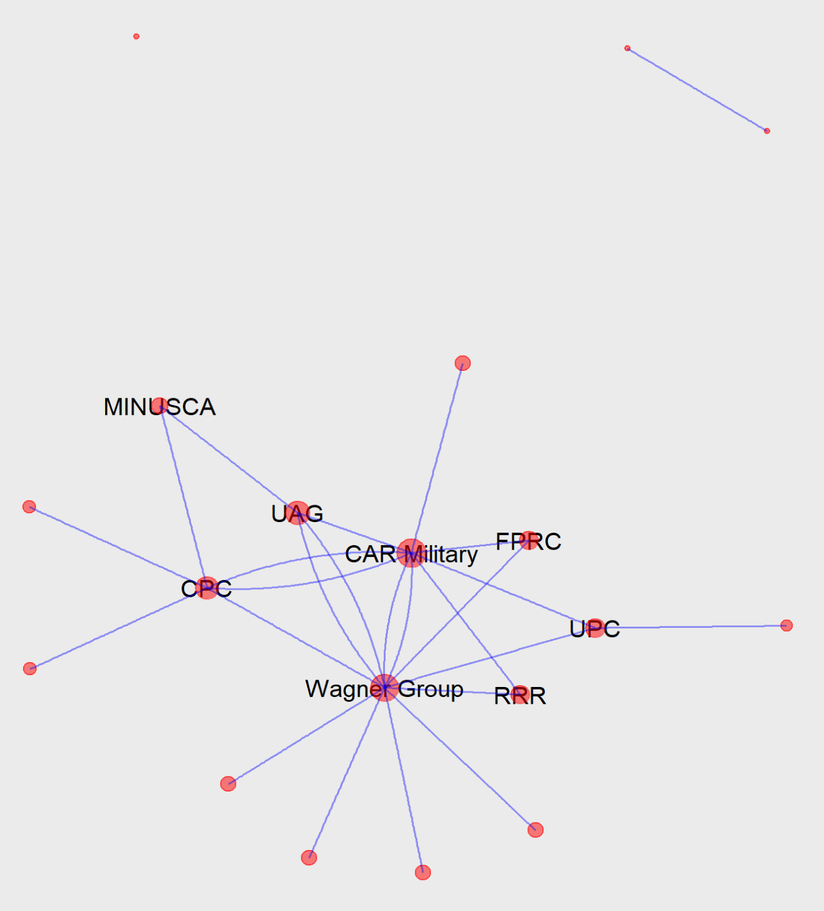

Link: <https://dai-analytics.shinyapps.io/car_sna/>

Social network analysis of violent conflict events between state and non-state actors permits a more comprehensive understanding of conflict in CAR. Conflict leading up to the 2013 ceasefire was largely organized around fighting between the Seleka Militia and CAR Military until the rebel foces successfully overthrew the government. While Djotodia disbanded the Seleka coalition, the militia continued to fight up until 2017 and many splinter and adjacent groups such as the UPC, RRR, FPRC, and MPC subsequently were formed during this time. As such, the conflict from 2014-2017 was largely between the Seleka Militia and Anti-Balaka forces, which are mainly composed of Christian populations. This violence spilled out among civilians and both groups have committed many atrocities against their own population. From July 2017 until the elections of 2020, many of these splinter groups of the Seleka became the main actors in conflict with the Anti-Balaka. There is also evidence of fighting amongst themselves, particularly between the Fulani-dominant UPC and the Gula and Runga dominant FPRC. This period is also characterized by the Anti-Balaka engaging in intense violent conflict with the CAR military and UN-led MINUSCA forces.

There were also important secondary actors who are engaged in conflict during this time, such as the Lord’s Resistance Army (LRA), which have not been primarily involved in armed conflict with any of the major actors mentioned above. Many violent events involving the LRA have been with communal militias (Bali-Fondo Communal Militia, Kpata Communal Militia, Madonguere Communal Militia, Mbangana Communal Militia).

In the most recent stage of the conflict (Jan 2021-Present), a major source of violent conflict is a series of events between the CPC and Russian private military force Wagner Group, which have been heavily involved in supporting the government of President Touadera. The most recent spike in conflict observed in 2021 has largely been to events involving these two actors. The next section will focus on the high number of events of violence against civilians involving these groups.

**A Deeper Dive on Violence Against Civilians involving the Wagner Group and CPC**

An important dynamic to the increase in conflict in 2021 is the increased incidence of violence against civilian populations. These events have largely been attributed to the Wagner Group and CPC, both actors who have been engaged in intense conflict between each other.

As the conflict between these groups has intensified, so have their involvement in violent events against civilian groups. The presence of the Wagner Group is also very recent. For example, in 2019 and 2020, there were only three violent events attributed to the Wagner Group whereas in 2021 this increased to 154 total violent events. Unsurprisingly, a similar dynamic plays out with the CPC since the groups founding in 2020 – in 2021, a total of 189 violent events against civilians occurred while only 14 took place in 2020.

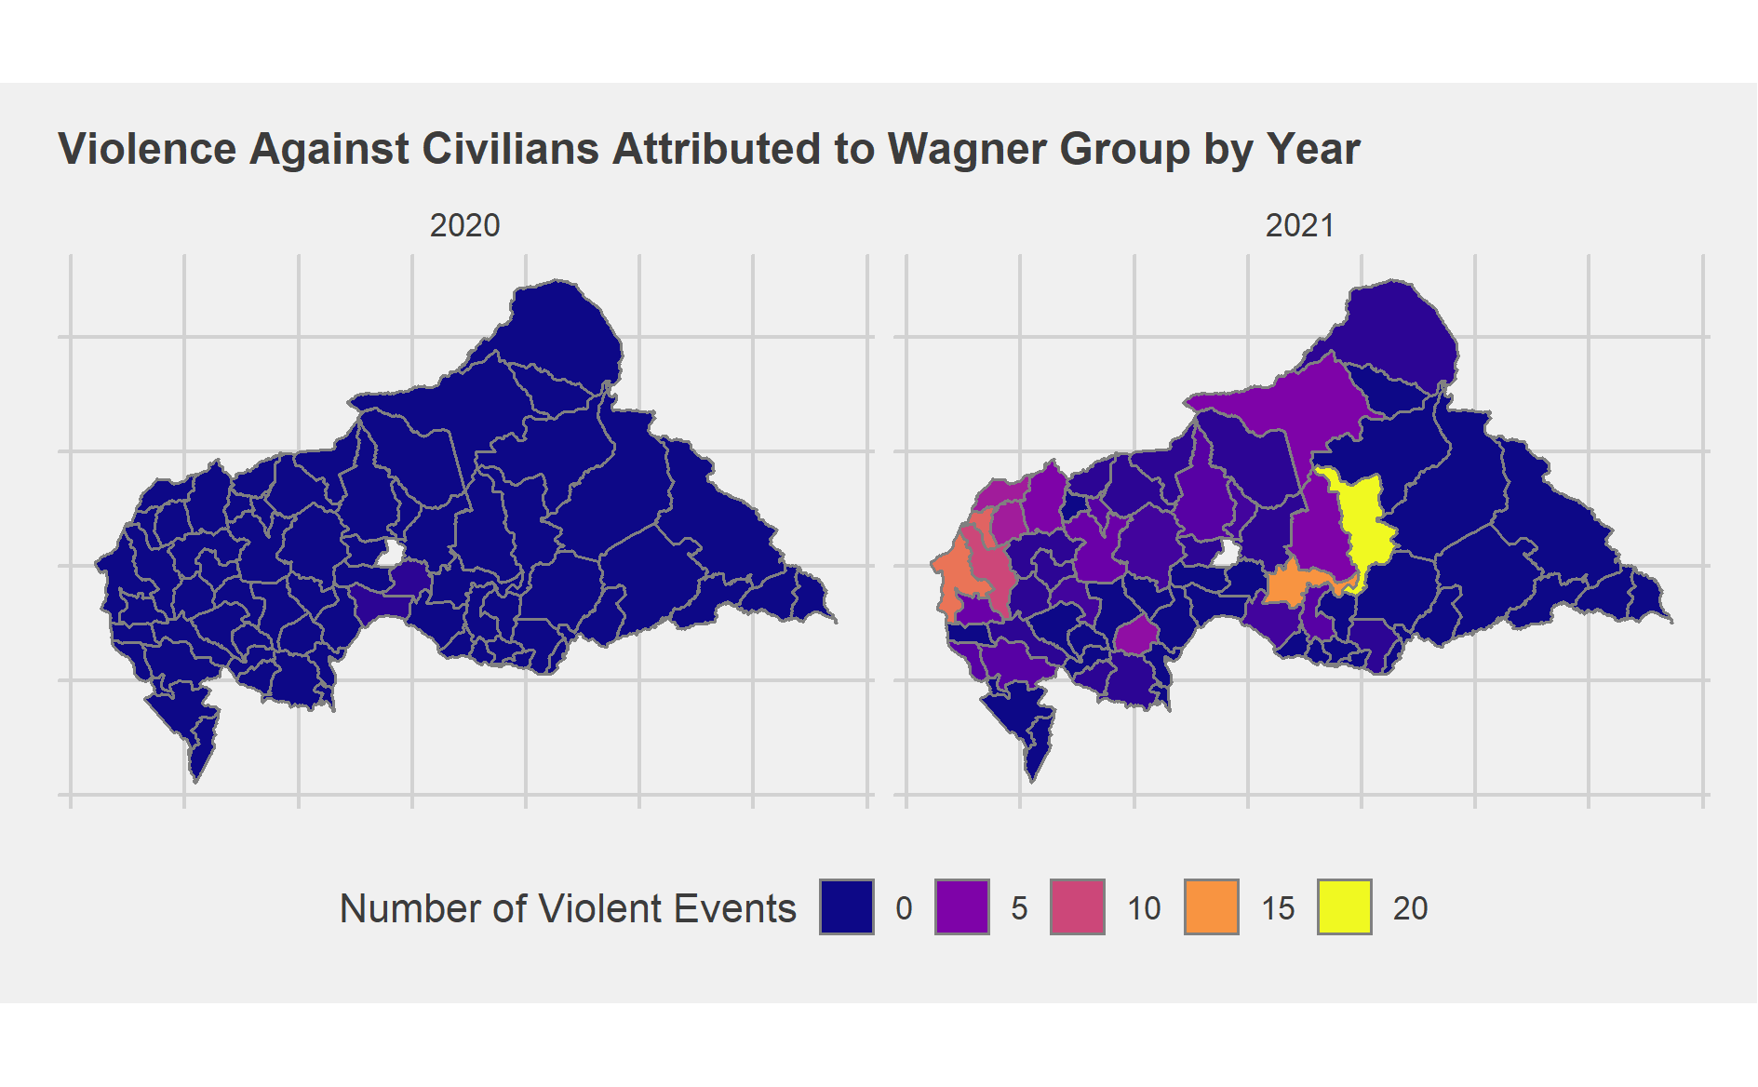

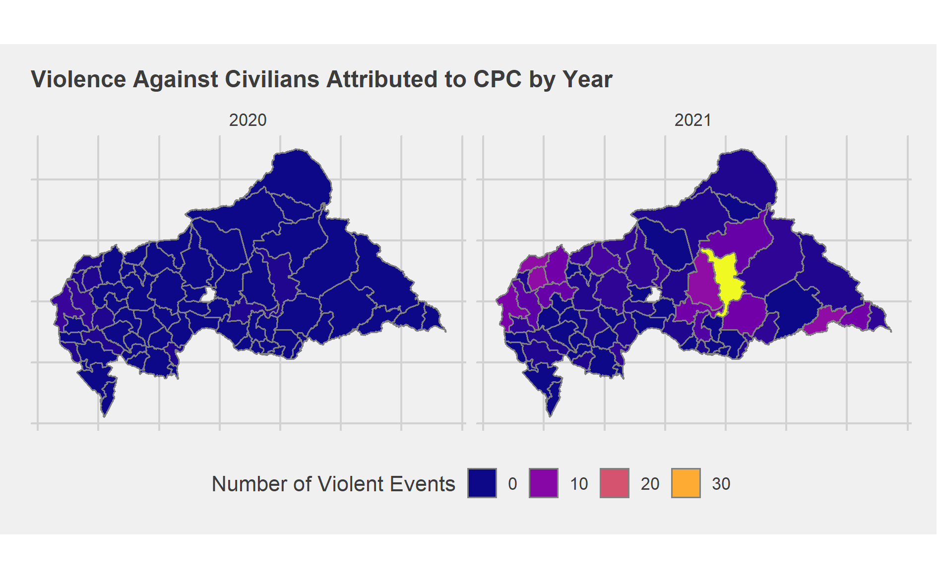

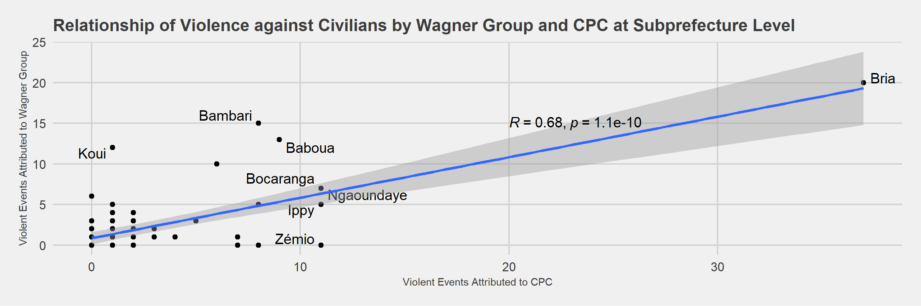

Are these violent events against civilians attributed to these different actors occurring in the same locations? There is strong evidence that this is the case – the high levels of incidence of violent events against civilians attributed to the Wagner Group and CPC is largely occurring in the same subprefectures located in the central and northwestern parts of the country. This is particularly true in the subprefecture of Bria in the center of the state, where fighting over access to diamond mines has spilled into the civilian population. Despite this relationship, we also observe relatively higher levels of violence against civilians attributed to the Wagner Group in the northwestern subprefectures such as Koui, Bambari and Baboua. Meanwhile, violent events against civilians attributed to the CPC have been observed in the southwestern subprefectures of Zemio and Obo, regions where the Wagner Group has little to no significant presence.